Reference link :

<https://tecadmin.net/install-java-8-on-centos-rhel-and-fedora/>

<https://www.liquidweb.com/kb/install-java-8-on-centos-7/>

1. **Step 1: Download Latest Java Archive**

***# cd /opt/***

***# wget*** [***https://download.oracle.com/otn-pub/java/jdk/8u201-b09/42970487e3af4f5aa5bca3f542482c60/jdk-8u201-linux-x64.tar.gz***](https://download.oracle.com/otn-pub/java/jdk/8u201-b09/42970487e3af4f5aa5bca3f542482c60/jdk-8u201-linux-x64.tar.gz)

***# tar xzf jdk-8u201-linux-x64.tar.gz***

1. **Install Java 8 with Alternatives**

***# cd jdk1.8.0_201/***

***# alternatives --install /usr/bin/java java /opt/jdk1.8.0_201/bin/java 2***

***# alternatives --config java***

The newly installed Java version listed at number 4, So input 4 and press enter.

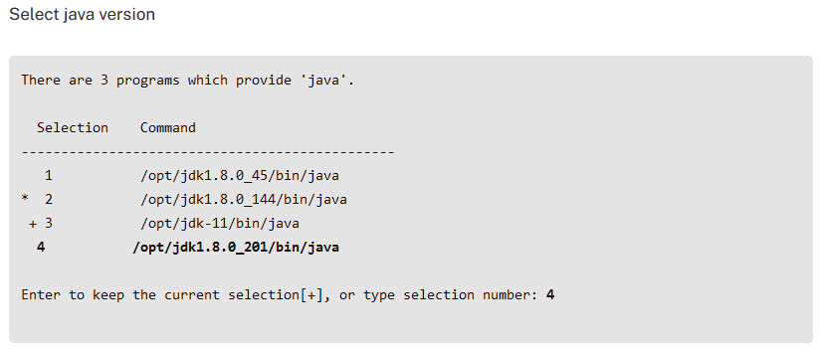

At this point, JAVA 8 has been successfully installed on your system.

also recommend to setup javac and jar commands path using alternatives

***# alternatives --install /usr/bin/jar jar /opt/jdk1.8.0_201/bin/jar 2***

***# alternatives --install /usr/bin/javac javac /opt/jdk1.8.0_201/bin/javac 2***

***# alternatives --set jar /opt/jdk1.8.0_201/bin/jar***

***# alternatives --set javac /opt/jdk1.8.0_201/bin/javac***

1. Check Installed Java Version

***# java -version***

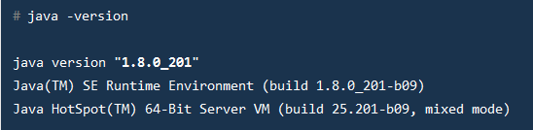

1. **Setup Java Environment Variables**

Most of Java based application’s uses environment variables to work. Set the Java environment variables using following commands

Set the JAVA_HOME, JRE_HOME and PATH environment variables.

***# export JAVA_HOME=/opt/jdk1.8.0_201***

***# export JRE_HOME=/opt/jdk1.8.0_201/jre***

***# export PATH=$PATH:/opt/jdk1.8.0_201/bin:/opt/jdk1.8.0_201/jre/bin***

Also add the above commands to **/etc/bashrc** or **/etc/environment** file to auto set environment variables during the system reboot.

1. Alternate wayt for step 4 to set java environment variable:

Most of Java based application’s uses environment variables to work. Set the Java environment variables using following commands.

Set the JAVA_HOME, JRE_HOME and PATH environment variables.

**# vi ~/.bash_profile**

set JAVA_HOME

**JAVA_HOME=/opt/jdk1.8.0_161**

**export PATH=$PATH:$JAVA_HOME/bin;**

Now execute below command to effect the change in /.bash_profile

# source ~/.bash_profile

Check **JAVA_HOME** by executing below command

# echo $**JAVA_HOME**